
d
Enterprise, Governance, Risk and Compliance Platform

Authentication against

Active directory using Kerberos

with EGRCP 6.x on Windows

August 2013

Draft

JBOSS server configuration

EGRCP Configuration Changes

Testing

Copyright Notices
Copyright © 2011 MetricStream Inc., All Rights Reserved.
The Enterprise, Governance, Risk and Compliance Platform 6.x AUTHENTICATION AGAINST ACTIVE DIRECTORY USING KERBEROS ON WINDOWS, as well as the software described within it, is furnished under license and may only be used or copied within the terms of that license. The information in this document is provided for informational purposes only, is subject to change without notice, and should not be construed as a commitment by MetricStream, Inc. MetricStream, Inc. assumes no responsibility or liability for any errors or inaccuracies that may appear in this document.
Except as permitted by license, no part of this publication may be reproduced, stored in a retrieval system, or transmitted, in any form or by any means – electronic, mechanical, recording, or otherwise – without the prior written permission of MetricStream, Inc.
Written and designed at MetricStream, Inc., 2600, East Bayshore Rd., Palo Alto, CA, 94065, U.S.A.
Printed in the U.S.A.
CAUTION
This document contains proprietary, confidential information that is the exclusive property of MetricStream, Inc. If you do not have a valid contract with MetricStream for the use of this document, or have not signed a non-disclosure agreement with MetricStream, then you received this document in an unauthorized manner and are not legally entitled to possess or read it.
Use, duplication, and disclosure are subject to restrictions stated in your contract with MetricStream, Inc. Use, duplication, and disclosure by the Government are subject to restrictions for commercial software and shall be deemed to be Restricted Rights software under Federal Law.
Document Change Control
Date | Author | Document Version | Change Reference
AUG 29,2013 | Brahmaiah | 1.0
- This section needs to be removed before we convert to a PDF. The Change Control section is not used in the PDF currently.

Table of Contents

Preface v
Feedback vi
Chapter 1. Introduction viii
Prerequisites viii
Chapter 2. User provisioning ix
Chapter 3. Jboss Server Configuration x
Chapter 4. EGRCP Configuration file settings xiii
Chapter 5. Testing xiv
Chapter 6. Troubleshooting xvii

Preface
This guide provides information on the ACTIVE DIRECTORY USING KERBEROS on MetricStream Enterprise Governance, Risk and Compliance Platform 6.1 SP2 (GRC Platform) application. The MetricStream Enterprise, Governance, Risk and Compliance Platform 6.1 SP2 application is a web-based application.
Feedback
MetricStream welcomes customers' comments and suggestions on the quality and usefulness of this document.
Your feedback is important, and helps us to best meet your needs as a user of our products. For example:
- Did you understand the context of the procedures?
- Did you find any errors in the information?
- Does the structure of the information help you to complete your tasks?
- Do you need different information or graphics? If so, where, and in what format?
- Are the examples correct? Do you need more examples?
If you find any errors or have any other suggestions for improvement, then please tell us.
Send your comments to us using the electronic mail address: docteam@metricstream.com
Please give your name, address, electronic mail address, and telephone number (optional).
If you need assistance with MetricStream software, then please contact MetricStream Support Services at support@metricstream.com or reach us at 800-858-5658.
If you require training or instruction in using MetricStream software, then please contact MetricStream office.
A list of MetricStream offices is available on our Web site at http://www.metricstream.com/

Introduction
This document provides information on Authentication against Active directory using Kerberos with EGRCP 6.x on WINDOWS machine.

Prerequisites
1. MetricStream EGRCP should be up and running on Apache and Jboss servers
2. AD server and Application server Time’s should be in synchronize.
3. LDAP Configuration has to be completed in the MetricStream EGRCP application.
4. Get the spnego-r7.jar file from MetricStream.

Notations Used

NOTATION | DESCRIPTION | ACTUAL VALUE
LDAP_SERVER_HOST | Windows Active directory machine.  Hostname: msi-dc01.metricstream.com
APP_SERVER_HOST | Installed EGRCP application machine.  Hostname: msi-l654.metricstream.com
METRIC_ROOT | Directory created for MetricStream EGRCP Application.  Default considered is D:\MetricStream
APACHE_HOME | Directory where Apache is installed.  Default is D:\MetricStream\SYSTEMi\Apache
JBOSS_HOME | Directory where Apache is installed.  Default is D:\jboss512\jboss-eap-5.1\jboss-as

- Fill in the actual values and take a printout before proceeding with the installation.
- This table has been given as a separate word document, to enable ease of use.

User provisioning

- Login into EGRCP application with SYSTEMI privileges.

- Navigate to users tab under System tab.

- Create users or pull the users from the LDAP.

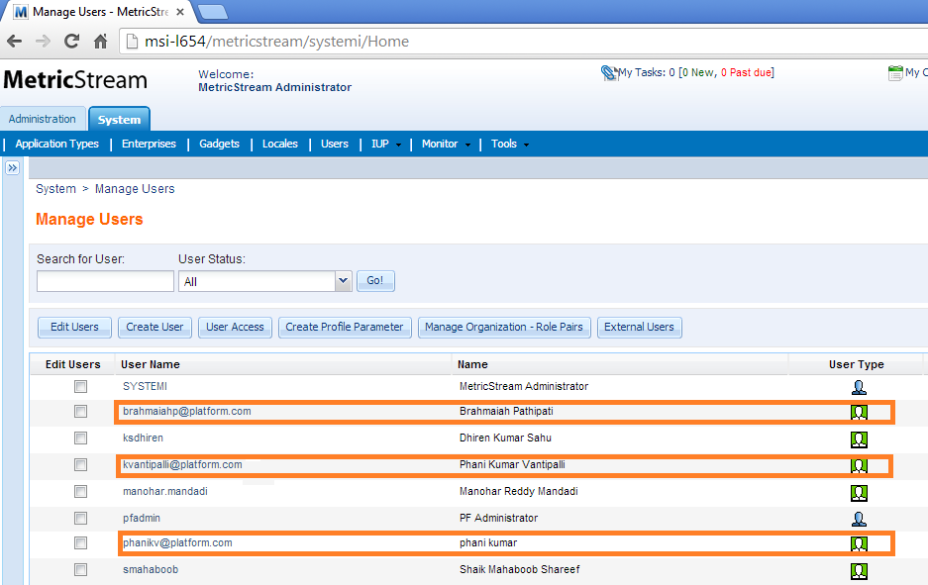

- User name should be along with domain name.
- Cross verify the User details in the database si_users_t table.

- Ex: username@DOMAIN.COM

Jboss Server Configuration

- Create a file with the name of krb5.conf and copy the below content into the krb5.conf file. Save the file into the <JBOSS_HOME>\bin folder.
[libdefaults]
default_realm = PLATFORM.COM
default_tgs_enctypes = rc4-hmac,aes256-cts-hmac-sha1-96,aes128-cts-hmac-sha1-96
default_tkt_enctypes = aes128-cts rc4-hmac des3-cbc-sha1 des-cbc-md5 des-cbc-crc
default_tgs_enctypes = aes128-cts rc4-hmac des3-cbc-sha1 des-cbc-md5 des-cbc-crc
permitted_enctypes = aes128-cts rc4-hmac des3-cbc-sha1 des-cbc-md5 des-cbc-crc
ticket_lifetime = 36000

[realms]
PLATFORM.COM = {
kdc = 172.27.5.59
admin_server = bnwsusr259
default_domain = PLATFORM.COM
}

[domain_realm]
platform.com= PLATFORM.COM
.platform.com= PLATFORM.COM

[appdefaults]
autologin = true
forward = true
forwardable = true
encrypt = true

- Change the values according to your configuration.
- The PLATFORM.COM is the Domain name of the Active Directory Server.
- Make sure pass the kdc value as an IP address of the Active Directory Server.
- All are case sensitive.

- Open the login-config.xml file from <JBOSS_HOME>\server\default\conf directory and copy the below content before to the </policy> tag (before the end of line in the file)
<application-policy name="spnego-client">
<authentication>
<login-module code="com.sun.security.auth.module.Krb5LoginModule"
flag="required" />
</authentication>
</application-policy>

<application-policy name="spnego-server">
<authentication>
<login-module code="com.sun.security.auth.module.Krb5LoginModule"
flag="required">
<module-option name="storeKey">true</module-option>
</login-module>
</authentication>
</application-policy>

- Open the file web.xml from the <JBOSS_HOME>\server\default\deployers\jbossweb.deployer directory.
- Search for <filter> tag and start the comment from <filter> to </context-param> tag. After the commentout it’s looks like as mentioned below.

<!-- <filter>
<filter-name>CommonHeadersFilter</filter-name>
<filter-class>
org.jboss.web.tomcat.filters.ReplyHeaderFilter</filter-class>
<init-param>
<param-name>X-Powered-By</param-name>
<param-value>Servlet 2.5; JBoss-5.0/JBossWeb-2.1</param-value>
</init-param>
</filter>

<filter-mapping>
<filter-name>CommonHeadersFilter</filter-name>
<url-pattern>/*</url-pattern>
</filter-mapping> -->

- Copy the below content after completion of the comment out from the above point#4. (below to the </filter-mapping> -->)

<filter>
<filter-name>SpnegoHttpFilter</filter-name>
<filter-class>net.sourceforge.spnego.SpnegoHttpFilter</filter-class>
<init-param>
<param-name>spnego.allow.basic</param-name>
<param-value>true</param-value>
</init-param>
<init-param>
<param-name>spnego.allow.localhost</param-name>
<param-value>true</param-value>
</init-param>
<init-param>
<param-name>spnego.allow.unsecure.basic</param-name>
<param-value>true</param-value>
</init-param>
<init-param>
<param-name>spnego.login.client.module</param-name>
<param-value>spnego-client</param-value>
</init-param>
<init-param>
<param-name>spnego.krb5.conf</param-name>
<param-value>krb5.conf</param-value>
</init-param>
<init-param>
<param-name>spnego.login.conf</param-name>
<param-value>login.conf</param-value>
</init-param>
<init-param>
<param-name>spnego.preauth.username</param-name>
<param-value>kvantipalli</param-value>
</init-param>
<init-param>
<param-name>spnego.preauth.password</param-name>
<param-value>R3setPassw0rd</param-value>
</init-param>
<init-param>
<param-name>spnego.login.server.module</param-name>
<param-value>spnego-server</param-value>
</init-param>
<init-param>
<param-name>spnego.prompt.ntlm</param-name>
<param-value>true</param-value>
</init-param>
<init-param>
<param-name>spnego.logger.level</param-name>
<param-value>1</param-value>
</init-param>
</filter>
<filter-mapping>
<filter-name>SpnegoHttpFilter</filter-name>
<url-pattern>/systemi/*</url-pattern>
</filter-mapping>

- Provide an correct LDAP values for the Below param-names
spnego.preauth.username
spnego.preauth.password
- All are case sensitive.

- Copy spnego-r7.jar file into the <JBOSS_HOME>\server\default\lib directory.

Security settings in server.xml
- Open the server.xml file from the <JBOSS_HOME>\server\default\deploy\jbossweb.sar folder.
- Search for the pattern (protocol="AJP/1.3") without braces in the server.xml.
For e.g.
<Connector protocol="AJP/1.3" port="8009" address="${jboss.bind.address}" redirectPort="8443" />
- Connector port value can change according to your server configuration.
- Append the attribute (tomcatAuthentication=”false”) without braces to the existing line as shown below
<Connector protocol="AJP/1.3" port="8009" address="${jboss.bind.address}" redirectPort="8443" tomcatAuthentication=”false” />
- Connector port value can change according to your server configuration.
- Manually replace the double quotes in the (tomcatAuthentication=”false”)
- After modification save and close the server.xml file.

EGRCP Configuration file settings

- Open the config.client.xml file in the directory D:\MetricStream\SYSTEMi\Systemi\Config using any editor tool.
Note: Change the D:\MetricStream\SYSTEMi\Systemi\Config to your
<METRIC_ROOT>\SYSTEMi\Systemi\Config
- Search for the property name “SIGNON_AGENT” without braces in the config.client.xml and change/keep the property value as mentioned below.
<PROPERTY NAME="SIGNON_AGENT">com.metricstream.systemi.client.plugin.sso.RemoteUserSA</PROPERTY>

- Search for “CASE_SENSITIVE_USER_NAMES” without braces in the config.client.xml and change/keep the property value as mentioned below
<PROPERTY NAME="CASE_SENSITIVE_USER_NAMES">NO</PROPERTY>
- After modification save and close the config.client.xml file.
- Restart the apache and Tomcat Services.

Testing
1. Open the browser and enter the URL

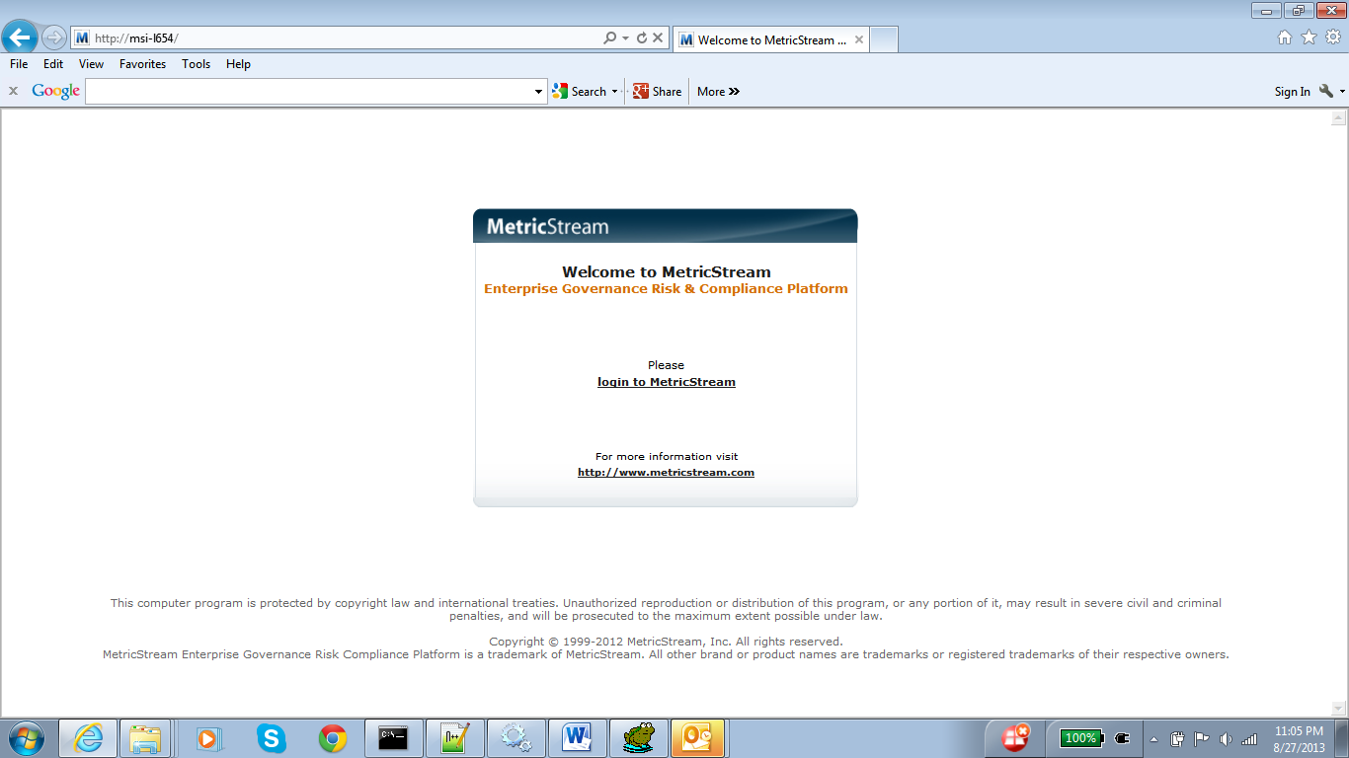

2. Click on Login to MetricStream, will get popup for User Credentials.

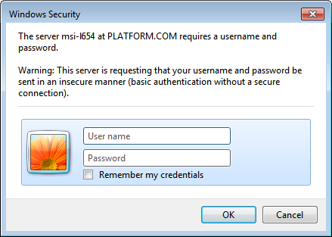

3. Now we are able to login into the application.

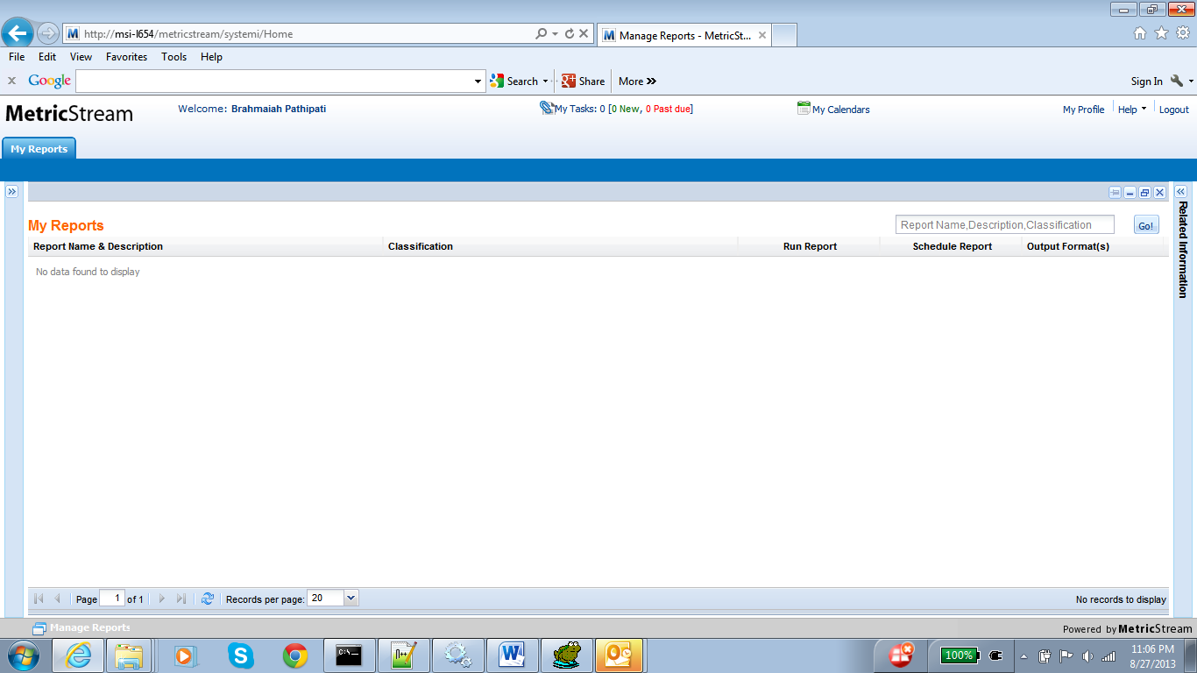

4. Check the displayHeaders.jsp.

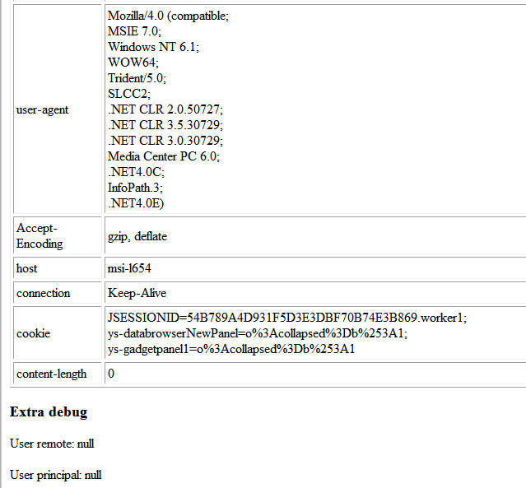

Troubleshooting
1. If we have an issue with restarting of the Tomcat service, check the catalina.xxxx.xx.xx.log file in the <TOMCAT_HOME>\log directory.

Error message in the catalina.xxxx.xx.xx.log

SEVERE: Parse Fatal Error at line 75 column 107: Open quote is expected for attribute "tomcatAuthentication" associated with an element type "Connector".
org.xml.sax.SAXParseException: Open quote is expected for attribute "tomcatAuthentication" associated with an element type "Connector".

Solution:

Issue with double Quotes( “ ” ) from the Point#6 in the chapter#3.
Manually replace the double Quotes in tomcatAuthentication=”false”

